Patient 7. Young woman with Down's Syndrome

Medical Conditions
Down’s Syndrome
Alzheimer’s Disease

Medications
None at Present

Drug Interactions and Metabolism
Cytochrome P 450 Subtype
Subtype indicated describes the specific isoenzymes of the P450 System responsible for the metabolism of the specific drugs patient has in their profile – this data can be found in Facts and Comparisons, Micromedex, The Drug Information Handbook, and is available to prescribers – It will likely be most accurate from these sources, which are at a fee.
(graphs indicate data we need to figure out how to obtain from genetic profiling and Pharm GKB) and provide to the prescriber!)
Patient is not on Medications at Present, however enzyme activity should be mapped
1A2
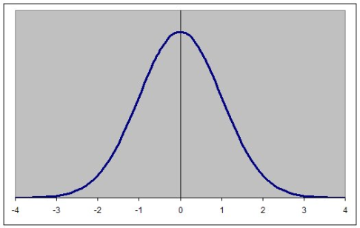
2C8
2C9

2C19

2D6

3A4 -

When agent is selected to treat Alzheimer’s or ALL, predictive pharmacogenomic data will be needed and matched to receptor variant disease

Genetic Information – Relating to Patient’s Diagnosis
Extra chromosome 21 - Down syndrome due to a Robertsonian translocation in the karyotype of one of the parents.
Acute Lymphoblastic Leukaemia
Cytogenetic translocation | Molecular genetic abnormality | %
cryptic t(12;21) | TEL-AML1 fusion^{[6]} | 25.4%^{[7]}
t(1;19)(q23;p13) | E2A-PBX (PBX1) fusion^{[8]} | 4.8%^{[7]}
t(9;22)(q34;q11) | BCR-ABL fusion(P185)^{[9]} | 1.6%^{[7]}
t(4;11)(q21;q23) | MLL-AF4 fusion^{[10]} | 1.6%^{[7]}
t(8;14)(q24;q32) | IGH-MYC fusion^{[11]}
t(11;14)(p13;q11) | TCR-RBTN2 fusion ^{[12]}

Implicated Biomarkers In Alzheimer’s Disease
T – Tau Absence
P –Tau Absence
AB42 Absence
APOE B4 Presence
ALL
Cytogenetic change | Risk category
Philadelphia chromosome | Poor prognosis
t(4;11)(q21;q23) | Poor prognosis
t(8;14)(q24.1;q32) | Poor prognosis
Complex karyotype (more than four abnormalities) | Poor prognosis
Low hypodiploidy or near triploidy | Poor prognosis
High hyperdiploidy (specifically, trisomy 4, 10, 17) | Good prognosis
del(9p) | Good prognosis
This Patient is in this category – Highlighted in Red
Correlation of prognosis with bone marrow cytogenetic finding in acute lymphoblastic leukemia
Prognosis | Cytogenetic findings
Favorable | Hyperdiploidy > 50 ; t (12;21)
Intermediate | Hyperdioloidy 47 -50; Normal(diploidy); del (6q); Rearrangements of 8q24
Unfavorable | Hypodiploidy-near haploidy; Near tetraploidy; del (17p); t (9;22); t (11q23)

Immunophenotypic categories of acute lymphoblastic leukemia (ALL)
The use of a TdT assay and a panel of monoclonal antibodies (MoAbs) to T cell and B cell associated antigens will identify almost all cases of ALL.
Types | FAB Class | Tdt | T cell associate antigen | B cell associate antigen | c Ig | s Ig
Precursor B | L1,L2 | + | - | + | -/+ | -
Precursor T | L1,L2 | + | + | - | - | -
B-cell | L3 | - | - | + | - | +

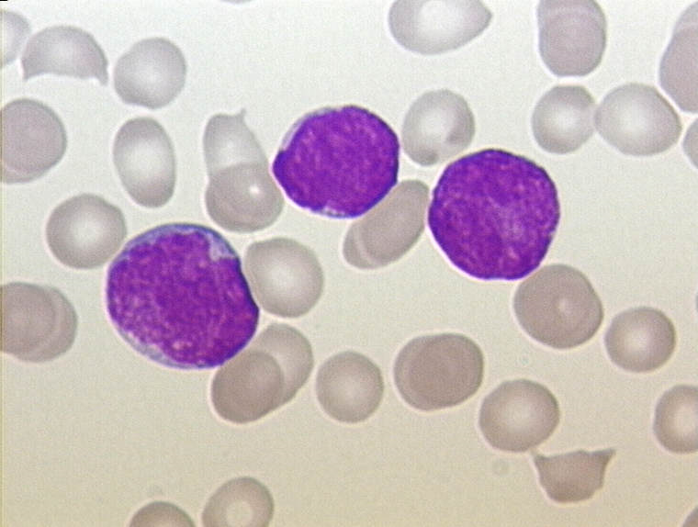
Blood Film of Patient
Should Include all films and dates they were performed

This Fake Patient’s Values are in the Far Right Column

Electrolytes and Metabolytess
Test | Range | Comments
Sodium (Na) | 130 - 145 mmol/L | 133
Potassium (K) | 3.5 - 5.0 mmol/L | 4
Urea | 2.6 - 6.8 mmol/L | 5
Creatinine | 50 - 110 μmol/L | 111
Glucose (fasting) | 4.2 - 6.1 mmol/L | 7

Liver function tests
Total Protein | 60 - 80 g/L | 62
Albumin | 30 - 50 g/L | 39
Total Bilirubin | 2 - 14 μmol/L | 20
Direct Bilirubin | 0 - 4 μmol/L | 2
Alanine transaminase (ALT) | 8 - 40 U/L | 22
Alkaline phosphatase (ALP) | 40 - 130 U/L | 122
Gamma glutamyl transferase | < 50 U/L | 242

Other enzymes and proteins
Creatine kinase (CK) | 22 - 198 U/L | 66
Aspartate transaminase (AST) | 8 - 35 U/L | 88
Lactate dehydrogenase (LDH) | 85 - 285 U/L | 222
Amylase | 25 - 125 U/L | 144
C-reactive protein (CRP) | <8 mg/L | 66

Other ions and trace metals
Ionised calcium (Ca) | 1.15 - 1.29 mmol/L | 1.01
Total calcium (Ca) | 2.05 - 2.55 mmol/L | 2.23
Copper (Cu) | 11 - 26 μmol/L
Zinc (Zn) | 10 - 17 μmol/L

Lipids
Triglycerides | 0.4 - 2.0 mmol/L | 2.6
Total cholesterol | 3.0 - 5.5 mmol/L | 5
HDL cholesterol (male) | 0.7 - 1.9 mmol/L | 1
(female) | 0.9 - 2.4 mmol/L
LDL cholesterol | 2.4 - 4.0 mmol/l | 4

Tumour markers
Alpha-fetoprotein (AFP) | 1-15 kIU/L
CA-125 | <65 kU/L
Prostate specific antigen (total PSA) | <2.0 μg/L

Hormones
Thyroid stimulating hormone (TSH) | 0.5 - 4.7 mIU/L | 2
Free thyroxine (FT₄) | 9.0 - 24 pmol/L | 17
Free triiodothyronine (FT₃) | 2.5 - 5.3 pmol/L | 5
Adrenocorticotropic hormone (ACTH) | 1.3 - 15 pmol/L | 3
Cortisol (0830 h) | 250 - 850 nmol/L | 522
Cortisol (1630 h) | 110 - 390 nmol/L
Prolactin (male) | <450 mIU/L
(female) | <580 mIU/L
Testosterone (male) | 8 - 38 nmol/L
(male prepuberty) | 0.1 - 0.5 nmol/L
(female) | 0.3 - 2.5 nmol/L

Haematology

Red blood cells
Haemoglobin (Hb) (male) | 130 - 180 g/L
(female) | 115 - 160 g/L | 133
Haematocrit (Hct) (male) | 0.38 - 0.52
(female) | 0.35 - 0.47
Mean cell volume (MCV) | 80 - 98 fL | 92
Mean cell haemoglobin (MCH) | 26 - 34 pg | 30
Red cell count (male) | 4.5 - 6.5 x10¹²/L | 6
(female) | 3.8 - 5.8 x10¹²/L
Reticulocytes | 10 - 100 x10⁹/L | 20
Erythrocyte  sedimentation rate (ESR) |  | 22

White blood cells
Total white blood cells | 4.0 - 11.0 x10⁹/L | 12
Neutrophil granulocytes | 2.0 - 7.5 x10⁹/L | 9
Lymphocytes | 1.0 - 4.0 x10⁹/L | 7
Monocytes | 0.0 - 0.8 x10⁹/L | 0.4
Eosinophil granulocytes | 0.0 - 0.5 x10⁹/L | 0.4
Basophil granulocytes | 0.0 - 0.2 x10⁹/L | 0.1

Coagulation
Prothrombin time (PT) | 7 - 10 s | 11
INR | 0.8 - 1.2 | 1.1
Activated partial thromboplastin time (APTT) | 29 - 41 s
Thrombin clotting time (TCT) | 11 - 18 s
Fibrinogen | 1.8 - 4.0 g/L | 3
Bleeding time | 2 - 8 minutes | 6

