

An Introduction to the Technical Components of Social Business
Version 1.0

Novenmber 2012
Contents
An Introduction to the Technical Components of Social Business Version 1.0 1
Acknowledgements 3
Social Business Community Group 3
Additional Reviewers 3
Introduction 4
What is a Social Business 5
Technical Components of Social Business 6
Sample Use Case: Business Process Visibility 7
Activity Streams 8
Gadgets and Embedding 9
Security 10
Social Graph 10
Summary of technical components applied to the business process use case 11
Additional Architectural Considerations 12
Application Architecture and SOA 12
Technology Architecture and Mobile Devices 13
Technology Architecture and Cloud Computing 14
Summary 14
Appendix A: The W3C Social Business Community Group 15
References 16
© 2012 W3C Social Business Community Group.

Acknowledgements
This document is extracted from the CTO’s Guide to Social Business, which is a collaborative effort from the W3C Social Business Community Group3 (SBCG). The SBCG brought together diverse business focused experiences and perspectives into a single guide for IT and business leaders who want to know more about social business. The following participants have provided their expertise and time to this effort.

Social Business Community Group
Ed Krebs (Ford)
Alberto Manuel (Process Sphere)
David Robinson (IBM)
Rich Rogers (IBM)
Ann Bassetti (The Boeing Company)
Don Buddenbaum (IBM)

Additional Reviewers
The following reviewers provided feedback on the Rapid Start Guide:
Alan Hamilton (Seric Systems Ltd)
David Hablewitz (Divergent Solutions LLC)
Viswanath Srikanth (IBM)

Introduction
The primary target audience for this paper is a technical audience looking to get a better understanding of technical components required to enable social business. According to Forrester Research, 65% of Line of Business buyers will buy IT solutions without involving their IT staff. Technical professionals need to be aware of social business trends and technology so that they can lead their organizations’ technical strategy as they become social businesses. Social business is an emerging area, as is the technology that enables it.

We are still early into the Fifth Shift in Business Technology
Mainframe
Departmental Computing
Personal Computing
Internet
Social Business
Source: Rawn Shah, 2/1/2011, Blogs.Forbes.com, The Fifth Shift in Business Technology, http://blogs.forbes.com/rawnshah/2011/02/01/the-fifth-shift-in-business-technology/
Adopting patterns from social networking into business settings is yielding new business needs that will drive new technology requirements needs and the need for flexibility realized via open standards. Social business is quickly expanding beyond social media campaigns and employee blog sites. Social business intersects with other important IT trends. Forbes observes that “businesses faces a dynamic landscape where both customer and employee demands are changing. The world is changing, and there are three market shifts that are driving this change – mobile, social, and cloud. These trends change what we connect, how we connect and how we transact. “1
Still, technology is only part of the equation. As automation is setting people free to put in practice tacit knowledge to handle more complex work. This means people will have to push their capabilities to new boundaries. This shift also has a profound implication on the type of people that companies will source in the labor market. The future worker profile will be aimed at highly-skilled persons capable of embracing business dynamics, socially driven and social oriented.

What is a Social Business
What is a social business? A social business is an organization that applies social networking tools and culture to business roles, processes and outcomes. A social business enables people to engage productively in a business context through collaboration and interconnecting business activities with social content. The scope of a social business spans across internal organizational boundaries and can extend to partners and customers. A social business monitors and analyzes social data to discover new insights that, when acted on, can drive business advantage, for example faster problem solving, improved customer relations, predicting market opportunities, and improving processes both internal and external. A social business recognizes that people do business with people and optimizes how people interact to accomplish organizational goals:
- Connecting individuals in productive, efficient ways
- Expediting identification of expertise
- Capturing and sharing knowledge
- Providing line-of-sight across traditional boundaries and better aligning actions to needs
- Speeding up business with insight to anticipate and address evolving opportunities
- Encouraging a collaborative atmosphere
The following diagram illustrates the range and categories of business processes that use social approaches.
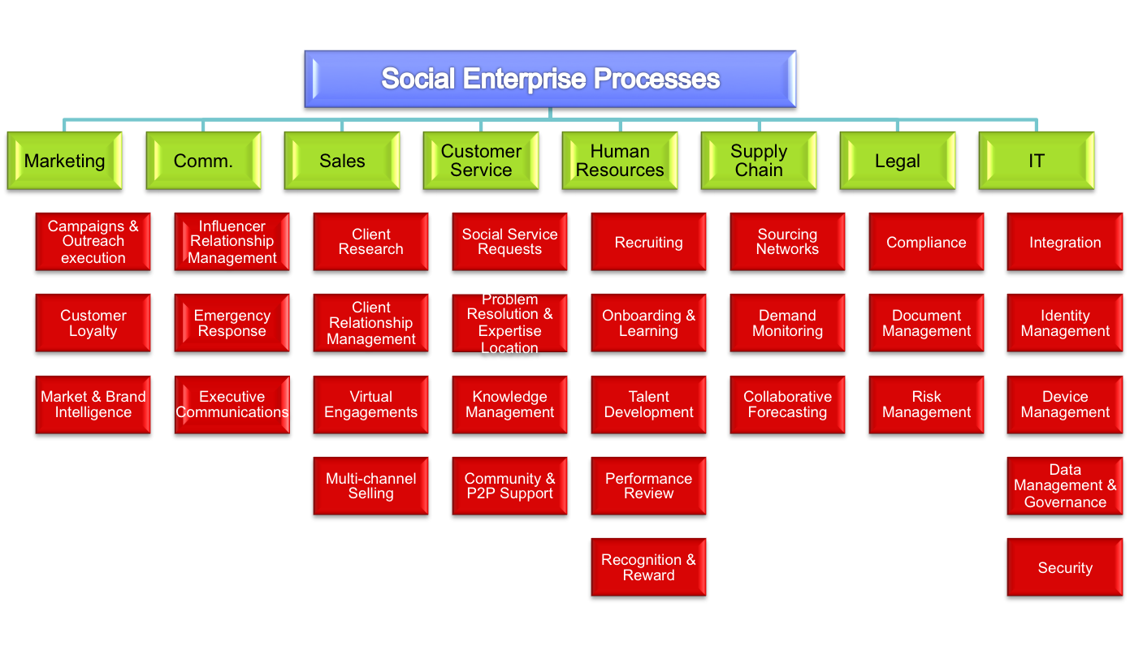

Chart Courtesy…..
Examples of social capabilities applied in businesses today:
- Marketing and Communications. Focused on use of social networking for marketing purposes. Emerging into more sophisticated customer relationship management scenarios that employ analytics capabilities; for example, brand monitoring via parsing and analyzing unstructured social content such as customer comments.
- Human Resources. Optimizing the workforce via collaboration software deployed to remove silos within an organization, improve information sharing and teaming, to achieve new innovation and more effective project teams.
- Project Management (IT). Providing a more fluid approach to commenting, documenting, updating and advancing a project through participatory methodologies such as blogging about meetings, commenting on documents.
- Cross-department collaboration. Facilitating awareness of activities and informal sharing of knowledge and resources across departmental boundaries with activity streams, blogs, and discussion forums.

Social business scenarios are emerging that are central to how work is accomplished in an organization. These will increasingly impact core systems within an enterprise. Consider, for example, supply chain business processes where social interaction is introduced to achieve more effective handling of business process exceptions, business process adoption and process improvement. These trends will increasingly reach deeper into an organization's core systems and impact enterprise architecture. Social business is not disjoint from enterprise IT strategy and execution, but rather an integral component.
What are the technical considerations of these emerging social business scenarios? The W3C (World Wide Web Consortium), a community that drives open web standards, led an online 3 day collaboration event (a “JAM”), on the subject of social business use cases and the standards required to support them. Over 1000 people participated, representing 20 industries, and including executives and thought leaders with varied backgrounds and specialties2. One recommendation from the JAM was the need to sustain the focus on open standards for social business. The result was the launch of the W3C Social Business Community Group, with a mission to “gather practical, business oriented, use cases focused on high-value transactions to influence and improve existing social standards in order to foster the growth and adoption of social standards in enterprise solutions. “3

Technical Components of Social Business
In this section we explore social technologies, how they are used to support the requirements presented by core business capabilities, and the associated standards that enable open, flexible, enterprise architectures. The building blocks of social business start from two points of origin. On one hand there are a wide variety of consumer-driven technologies and patterns that foster collaboration and new approaches to engaging the user and communities. On the other hand there are a broad set of technologies, standards, and services that drive existing line of business applications and systems. This point of convergence is where we start to drive new value and visibility to existing processes, applications and data. It's important to note that this transformation does not require a one-size-fits-all approach. An effective approach is to start small and incrementally add capabilities over time as illustrated in the following figure.
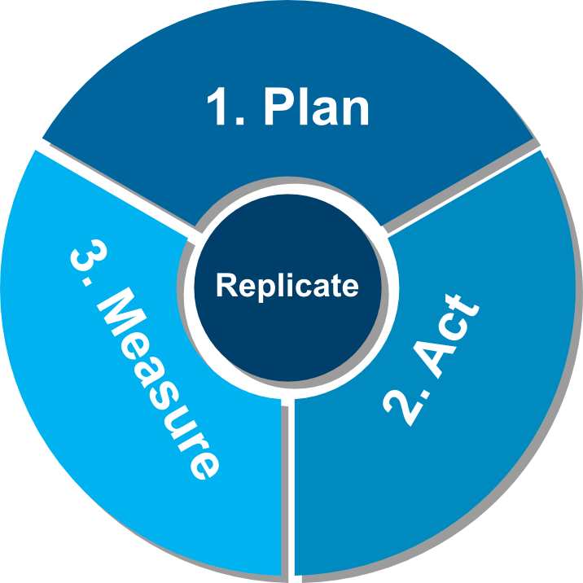
Plan – Identify your social business advocates and form a cross-functional team to develop your business case and articulate the expected returns from empowering processes with social capability
Act – Develop a proof of concept by leveraging a social platform to extend existing solution investments
Measure – Obtain stakeholder agreement for the proof of concept and establish the metrics of success by which social enablement for the project will be measured
Evaluate each implementation, replicate successes & build upon consecutive social investments to grow a comprehensive social business program
It's important to understand the technology and the fundamental building blocks as social capabilities are added into the environment. There are a few fundamentals that the technology team will encounter as they look at social technologies. Here is a brief description of the key components and some of the existing and emerging standards, many of which are supported by open source implementations.

The social platform
There is no common definition for a social platform. Most of the community work around it focus too much on the technology the platform provides rather on the semantics or meaning of such platform is.
A social platform can be understood as the capability provided to an organization to deploy and manage onto a infrastructure artifacts into the layers that constitutes the platform.
The layers reflect the internal and external social interactions an organization executes regarding the organization environment it belongs and evolve over time. Those interactions that constitute the social practice are driven by technology that best supports the nature of work executed by the people.
The problem of focusing on the technology that makes social business happen is it creates a tunnel vision of making it a reality because technology alone does not provide the foundation of creating a full integrated into the organization value chain that includes all the stakeholders.
The social platform is constituted by three main blocks as bellow illustration:
- About the Human: Who you are, how you identify yourself and what you pretend to be, the person’s social graph.
- Human Interactions: What you do. How do you express. How you engage. How do you react. Where you belong. What work you execute.
- Search and Analytics: Search for knowledge, gather feedback, get trends, spot patterns, sentiments, learn.

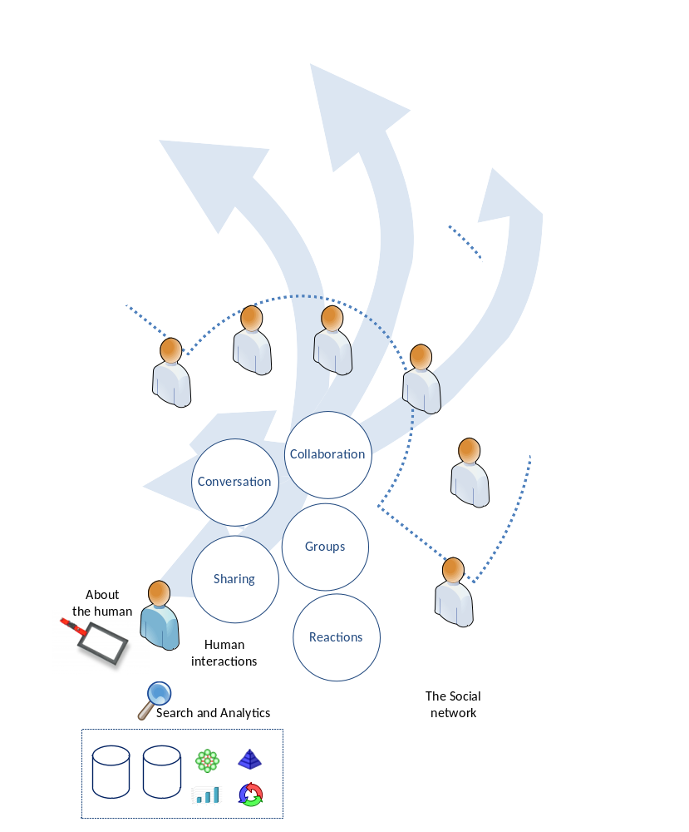
Figure 1 – The social platform

The social platform blocks
About the human is constituted by:
- Identity: Unique identification attributes about the human.
- Profile: What attributes about the human are available to identify him. Presence status (on-line / off-line …).
- Social Graph: Social network type, network type and network connections around particular domains (may exist different networks for different domains). The communication flow and how people are connected with. People can be connected through some kind of relationship (work with, partner of), but the most importantly is the information flow between the people, i.e. the working practice, information sharing, because is here where action occurs.
- Addressing: Contact details (e-mail, instant messaging … ).
- Reputation: Perceived evaluation taken by members of the social graph.
Human interactions are constituted by:
Messaging: Conversations can be synchronous or asynchronous around a topic.
- Group dynamics: Communities of interest or practice, interacting around a particular domain.
- Collaboration: Work being carried towards a goal that must be achieved. Work can be structured or unstructured.
- Sharing: Accepting an object to be shared in order others can take action if they want to.
- Reactions: Expressing a feeling about an object , making an opinion or making an evaluation.
- Ubiquitous attributes ?

Search and analytics is constituted by:
- Search : Find information necessary to gather data to reason to judge and execute tasks.
- Business Intelligence: Getting and explore data, finding trends, correlation helping people to do better decisions (if they know how to interpret it)
- Mining: Extract data and display it process oriented for business process analysis and improvement.

Appendix A: The W3C Social Business Community Group
We are in the formative stages of social business. Beyond pilots, beyond the getting started use cases, there are scores of valuable new and emerging use cases, yet to be imagined, defined, and implemented by the myriad of users challenged by their unique requirements. What we know is that whether enterprise, B2B, or B2C, an open standards-based ecosystem will most readily enable desired use cases to become reality with more flexibility of choice, with less time and cost. The real value of social business will not be realized if manifested as islands of point solutions. As social business becomes more pervasive, integration with core business systems, and across social platforms, will be desired. As we have seen with recent paradigms such as service oriented architecture (SOA) and Cloud, open standards are the enabler of this desired flexibility. The W3C Social Business Community Group is in place to define social business use cases that matter to businesses and drive the open standards based ecosystem needed to support those use cases.
The mission of the Social Business Community Group is to “gather practical, business oriented, use cases focused on high-value transactions to influence and improve existing social standards in order to foster the growth and adoption of social standards in enterprise solutions.”3
Consider joining the W3C Social Business Community Group. There is no membership fee, even if your organization is not currently a member of W3C. The W3C Social Business Community Group is a gathering place to understand the value of applying social concepts to business, share best practices with peers and subject matter experts, and influence the evolution of social business standards. The group is also producing a diagram to represent the various components of importance to social business, and the current standards landscape overlay, in order to identify and prioritize standards requirements for social business. Join the group and contribute your ideas.
For information on the Social Business Community Group, including how to join, visit this link - http://www.w3.org/community/socbizcg/

References

- “Three Trends that Change Business. Mobile, Social, and Cloud”, Forbes: http://www.forbes.com/sites/maribellopez/2012/01/28/three-trends-that-change-business-mobile-social-and-cloud/
- W3C Social Business Jam: http://www.w3.org/2011/socialbusiness-jam/report.html
- W3C Social Business Community Group: http://www.w3.org/community/socbizcg/
- Cloud Standards Customer Council: http://www.cloud-council.org/
- Activity Streams: http://activitystrea.ms/
- Gartner: http://www.gartner.com/it-glossary/enterprise-architecture-ea/
- The Open Group: http://pubs.opengroup.org/architecture/togaf8-doc/arch/
- Mell, P., & Grance, T. (2011). The NIST Definition of Cloud Computing (Draft): Recommendations of the National Institute. Gaithersburg: National Institute of Standards and Technology. http://csrc.nist.gov/publications/drafts/800-145/Draft-SP-800-145_cloud-definition.pdf This white paper defines cloud computing, the five essential characteristics, three service models, and four deployment models.

