Logistical Information
Bundang, Korea

1. Venue
Telecommunications Technologies Association(TTA)
Grand Conference room – A (9th floor)
47 Bundang-ro Bundang-gu Seongnam-si Gyeonggi-do, Korea, 13591
경기도 성남시 분당구 분당로 47한국정보통신기술협회(TTA)

Website: http://www.tta.or.kr/English/new/about/access.jsp

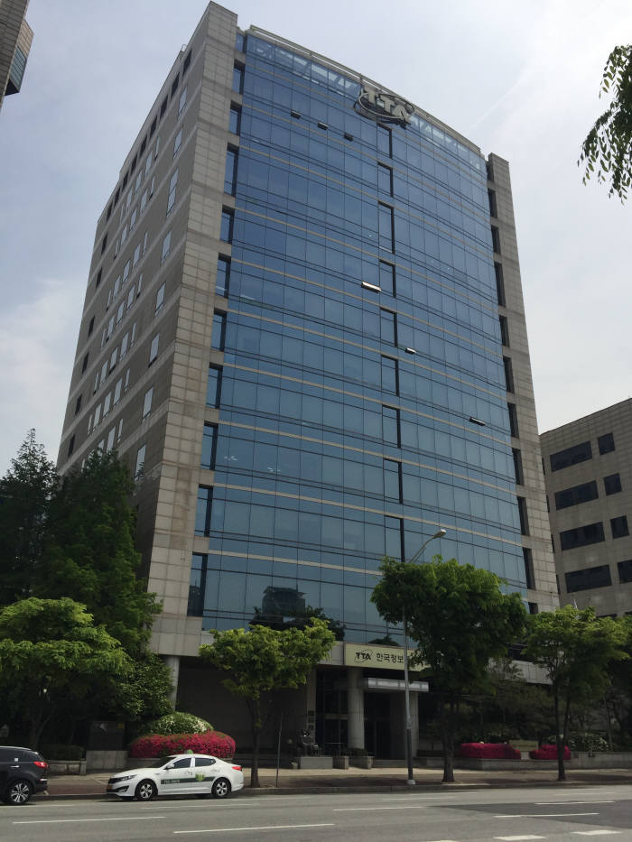

2. Transportation from the airport to the venue
Experts are requested to use public transportation facilities of the airport.

- Arriving at Incheon International Airport (ICN)
  - It takes from 70 to 80 minutes between Incheon International Airport and the hotels above by the bus.
  - Bus : Search for “Seohyeon(書峴 ,书岘站, 書ヒョン駅)” as your destination at http://www.airport.kr/
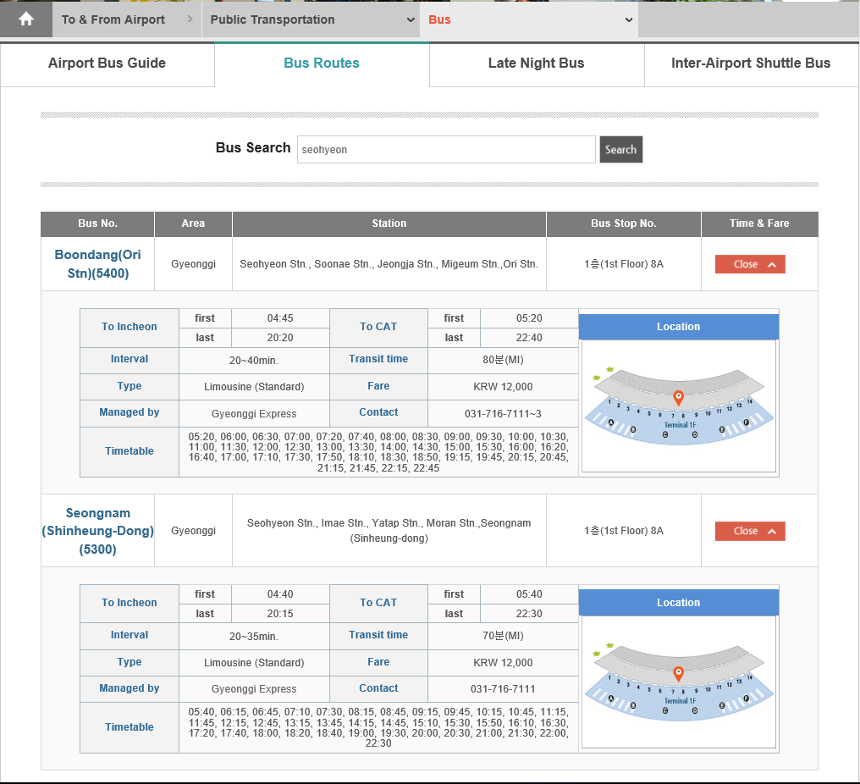
- Arriving at Gimpo International Airport (GMP)
  - It takes from 80 to 90 minutes between Gimpo International Airport and the hotels above by the bus.
  - Bus : Search for “Seohyeon(書峴 ,书岘站, 書ヒョン駅)” as your destination at : http://www.airport.co.kr/gimpoeng/extra/bus/busList/layOut.do?busType=I&cId=2016010811255234804&menuId=1834
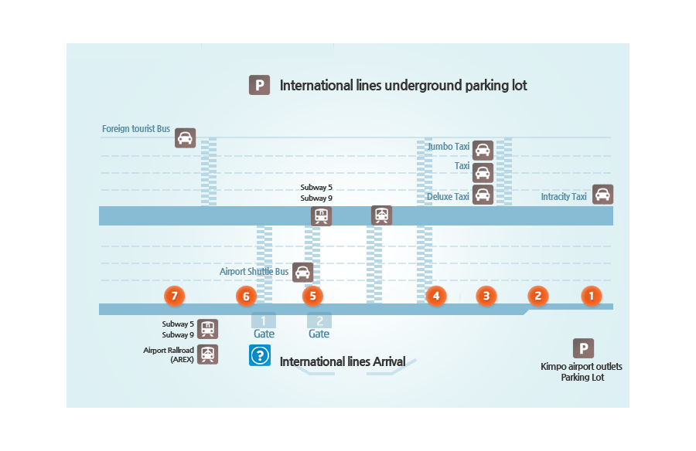
Stop for Seohyeon Stn.

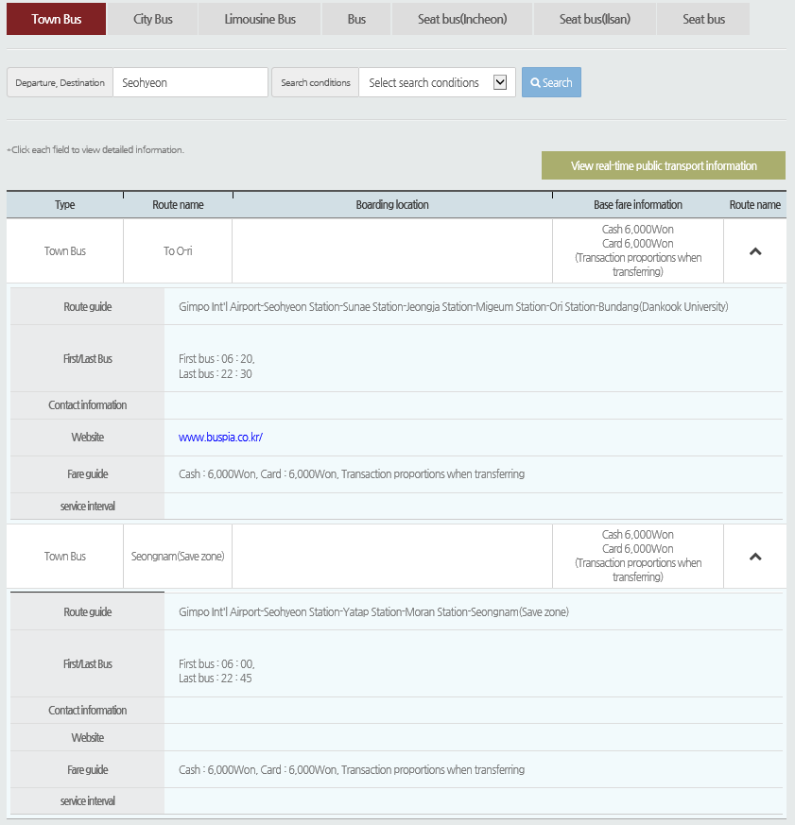
For your general information, the following public transportations are available from the Incheon International Airport to Seohyeon station.
- Subway : http://www.smrt.co.kr/program/cyberStation/main2.jsp?lang=e
- Public meter taxi: http://www.intltaxi.co.kr/?lang=en (approx. KRW45,000 ~ 55,000)

3. TTA and nearby map
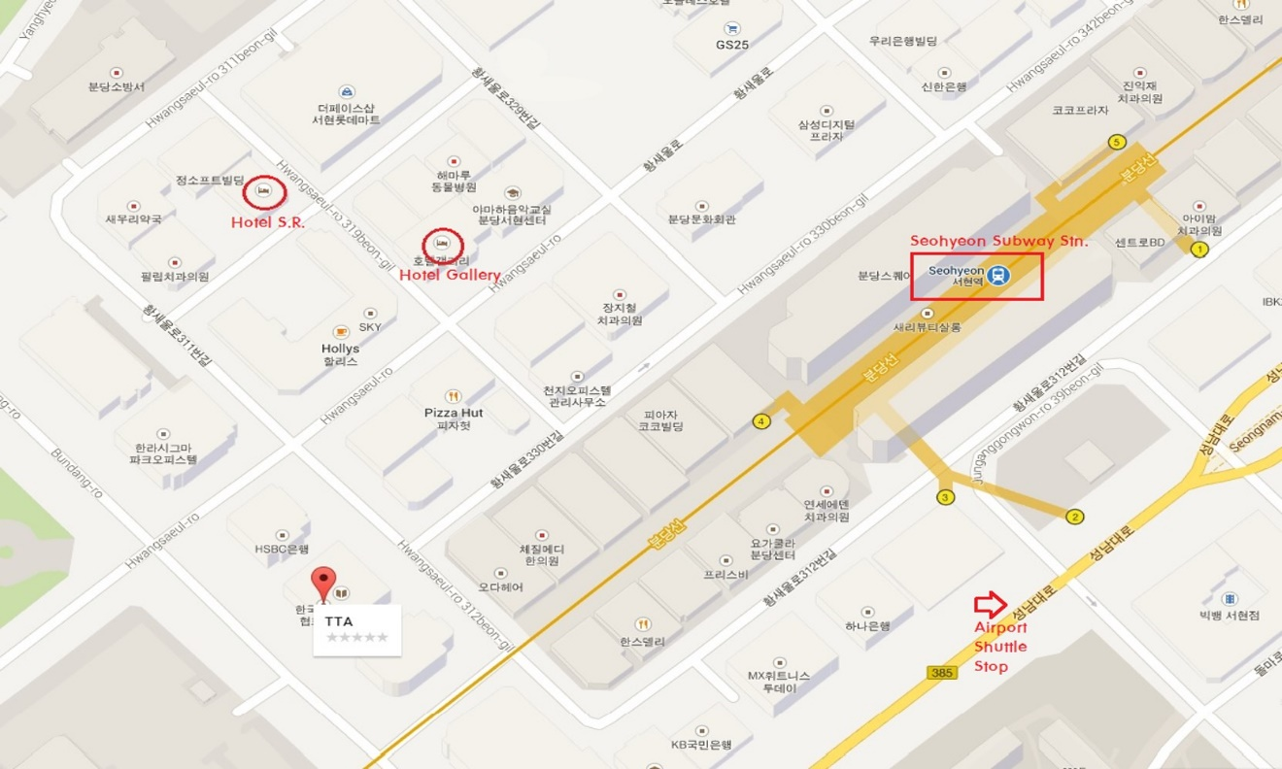

Google map: https://goo.gl/maps/XiXP1wWhmpS2

4. Currency and Credit Cards
The unit of Korean currency is Won. There are KRW10, KRW50, KRW100 and KRW500 coins, and KRW1,000, KRW5,000, KRW10,000 and KRW50,000 notes. For higher denominations, negotiable cashier’s checks are used. Major currencies and traveler’s checks can be exchanged into Korean won at the airport, hotels, and at all Korean banks. Credit cards, e.g. VISA, MasterCard, American Express, and Diners Club, are all widely accepted.

5. Tipping
Tipping is not a traditional Korean custom. Service charges are added to the bill but tipping is not expected. It is also not necessary to tip a taxi driver unless extra service are provided.

6. Wireless LAN & Electricity:
The meeting will be paperless and WLAN will be provided. Please make sure you have AC adapters for 220 volts at 60 Hz. (plug type C & F). Voltage converters will not be provided at the meeting.

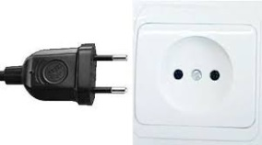 (Type C) 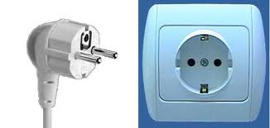 (Type F)

