0. Plan
- Project top-level description for W3M (and AB, Team)
- Write RFP, disseminate, choose winner
- Take over the world

Cycles of review
1. | Vivien, Webdesign TF | Top-level description + every step
2. | Jeff | Top-level description + most steps
3. | W3M | Top-level description + milestones
4. | Team | Top-level description + onboarding + feedback loop + Alpha
5. | AB | Top-level description + milestones
6. | Members | Heads-up about launch
7. | Public | Beta / Reveal at launch

Calendar/phases
- Sep-Oct 2019: research + top-level description of the project
  - Top-level description amended per W3M and AB input
  - … Run by Team for additional feedback
  - Write RFP
  - Identify channels (including Hosts) for RFP dissemination
- Nov-Dec 2019: RFP written, disseminated, project awarded
  - 06-Nov: RFP reviewed by Team; approved by W3M
  - 07?-Nov: Announce RFP
  - 29?-Nov: Bids due
  - 20?-Dec: Project awarded; notification to all bidders
- January 2019 - December 2020: website redesign
  - Detail TBD
    - One milestone is the availability of an architecture for the redesign which requires wide review and wide input (Team, AB, probably even beyond the Team+AB)
    - Once the architecture is fixed and we are into rebuilding the website then there are more operational views
      - Team members who work with the outside agency on a project team
      - A review panel who fields the inevitable questions from the project team
      - Schedule reviews
      - Migration planning
  - When to include some checkpoints for feedback loop?
  - Alpha (internal)
  - Beta/release candidate (pre-deployment)

1. Top-level description of what the website redesign effort will look like
➜ To run first by W3M before we get started

Project description
W3C believes that by implementing current web best practices and technologies, revising the information architecture, creating a content strategy and revamping the visual design, we can provide our audiences with the best information in a more user-friendly fashion, motivate participation in the organization, and communicate the nature and impact of the W3C more effectively.

Owner and project manager
Coralie (website is owned by MarComm)

Participants and roles
- Coralie: owner, decision-maker
- Vivien: advisor, decision-maker, may devote systeam resources
- Oversight team: Coralie, Vivien, Jeff, Ralph, Alan
- Bid reviewers: Coralie, Vivien, Jeff, Ralph, Tetralogical, Shawn?, Eric?, others?
- Systeam: total possible FTE TBD
- Webdesign TF (Bert, Tanya): consultation (total possible FTE:.50)
- Léonie offers Tetralogical time to advise (we could verify the accessibility credentials of potential suppliers, advise W3C on the way the chosen supplier plans to build accessibility into the project, or advise on possible solutions to accessibility challenges that arise throughout production.
We could also take a brief look at designs, prototypes etc. to verify that accessibility is being considered appropriately - though this would be in the form of expert analysis, not complete WCAG assessments (because those take time and money, and the chosen supplier is expected to do this themselves as part of their QA process))
- External expertise (agency + freelancers if appropriate): brunt of the work
- Team: buy-in, expertise (i18n, a11y, security, privacy)
- Notes:
  - Ian is happy to be consulted by Coralie in an ad-hoc fashion
  - WAI staff not available but should be able to provide some thoughts on how to plan and scope the accessibility work

Time frame
Launch of phase 1 in December 2020 (note: to be timed with launch of W3C Legal Entity in January 2021)

Why are we doing this?
- Our website is supposed to show the world who we are and what we offer (note: our website generates awareness, is informational for potential new Members or participants, is a tool for active participants, but is NOT a primary driver of sales)
- The website is well-designed but
  - Is hard to navigate
  - Is out-dated look and non consistently responsive
  - Has too much content that is unsorted
  - Lacks a cohesive look
- Also: 75% of people judge a business by its website (source)
- W3C will launch as its own Legal Entity in 2021

Objectives
- Solidify brand authority, consistent design, uniform appearance
- Create an engaging and easy to navigate experience
- Increase engagement (Members to join) and funding (crowdsourcing) (Join/Donate buttons)
- Ability to re-use redesign (to expand to other phases); enable us to evolve the style guide to cater for new needs & usages; likewise how we will be empowered to make the information architecture evolve based on new themes, priorities
- Optimize (layout, tooling) to make content that meets user needs (content design)
- Optimize presentation, then archive redundant/stale content (➜ inventory of the current content / URL Mapping and 301 Redirects)
- Simpler and robust editing/maintenance (we expect the markup+style to be as simple/minimal as possible, and easy to understand and update over time)
- Create a long-lasting partnership with a web design agency to work with us as our needs and organization evolve

Requirements
- Provide a modern replacement for the custom CMS used for the current site
  - We need a CMS that is long-lived and easy to maintain, because we run our systems for decades.
  - The CMS may need to enable collaborative editing
- Move to HTML5
- MFA ideally with webauthn, noting that the main challenge for us for MFA is integration with our unique environment (fine-grained ACL system, legacy software services)
- WCAG 2.1, ideally Level AAA (level AA as a minimum)
- Device-independent, reusable (i.e., semantically rich and machine-readable) and future-proof (i.e., in standard formats)
- Standards compliance
- Consistently responsive: mobile first, then desktop design
- Integrates with existing W3C-maintained back-end services (e.g. database of groups and participants, …)
- Modern best practices and simple, maintainable markup and CSS
- Redesigned website’s performance must be as good as or better than the current site

Scope
  - The first phase is a subset of the public-facing pages that are the most “corporate”:
- Website homepage
- Primary navigation targets which currently are(*):
    - "Standards"
    - "Participate"
    - "Membership"
    - "About"
    - https://www.w3.org/Consortium/*
- W3C Blog
- Vertical industries landing pages
- /TR homepage (only the frame)
- Account pages (request, my profile (**) (and its edit pages))
- Others as determined by information architecture
  - Design for overhaul in future phases consistent with phase 1 (see “phases” under the “questions” section): the design chosen for Phase I needs to look at the rest of the site, so we don’t run any risk that the Phase I work will not scale well to cover the requirements of the rest of the site.

(*) The four primary categories we have today are legacy pages and while they are appropriate moving forward we should clearly identify who the targets for the site are and then determine what that means from an architectural perspective.
(**) This page is not public-facing but the public account pages lead to it, hence it’s in scope.

Costing/budget
- Recent-ish estimations ranged from $15K to $300K. Responses to our RFP will give us even more recent idea of cost.
- When assessing responses, let’s not focus on getting the cheapest bid: a website redesign is costly but we have a lot at stake, AND we redesign on average only every 10 years.
- Web agency costs ought to include :
  - Information Architecture / wireframes (New website infrastructure)
  - Advice on software (e.g. CMS, analytics), content migration
  - Content Strategy
  - SEO strategy and re-directs
  - Visual Design
  - Mobile/responsive design
  - Advanced customisation
  - Style sheets and templates
  - Usability, Browser & Device Testing
  - Integration
  - Project Management
- In addition to paying a web agency:
  - Software (e.g. CMS, analytics)
  - Content migration
- The agency should be willing to work in the open: to publish and explain their work as it is completed in phases and collect and accept feedback from the W3C community

2. Request for proposals (RFP)
The RFP stems from top-level description.
Draft RFP available for AB/Team review:
https://docs.google.com/document/d/1u7OmpSaYBhV9HzBxJpjDneWACo9cS1obSZJgZ-boioQ/edit?usp=sharing
The draft RFP has been staged in https://www.w3.org/2019/11/website-redesign-rfp.html (not publicly available yet)

3. Take over the world
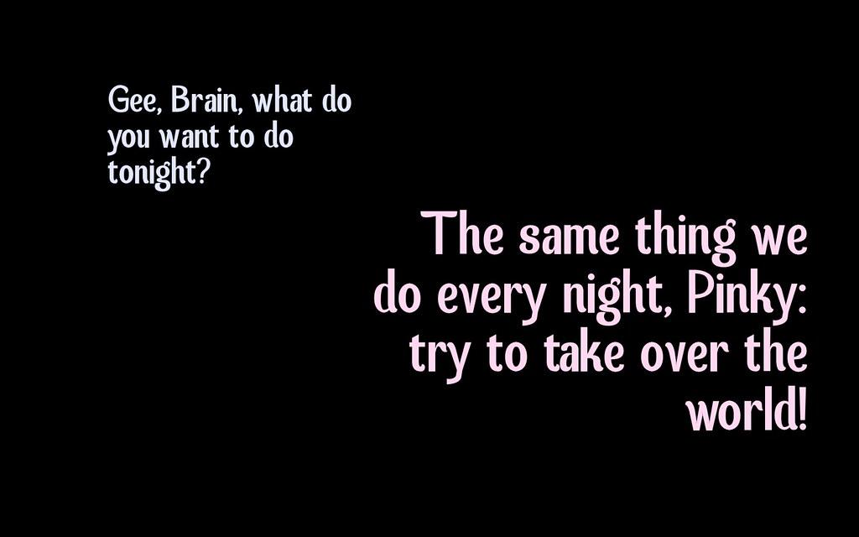

Questions
- What metrics to focus on?
➜ For the 2014 abandoned website redesign project, we had the following: https://lists.w3.org/Archives/Public/public-site-design/2013May/att-0022/web-stats.html
- Who ultimately edits the Website?
➜ Vivien: Comm mainly, Busdev some; let’s aim for a corporate site. WG/IG will have autonomy on their space.
- How do we integrate multilingual? Or is our website only in English as a single language? (we do language negotiation on w3.org in a limited number of cases, but in practice nobody does elsewhere)
➜
- Homepage current design:
➜ Vivien: It was designed at a time when no search engines existed and we had to put everything on it. Today it’s no longer needed and we do have a site map + “A to Z” => trim down homepage
- VL + CM: Preference is to hire an agency that handles our project in full.
- Phases:
➜ public-facing site first (a subset, see “scope” section)
➜ Next phases: Public work group pages, Member and team spaces, /TR page content, specifications template, mailing lists archives, CGs, media, dev, others?
- Do we need a complete overhaul with a new underlying structure, or just an improved look for the current site?
➜ Vivien: The current infrastructure is very likely not suited for handling a new design (eg our inability to switch to HTML5). This project will have to include a "new infrastructure" component.
- If we move to more dynamic pages, what will the impact be on performance?
➜ Vivien: Short answer: don’t worry about this. Longer answer: Systeam has solutions to serve dynamic pages efficiently (eg. caching) so this should not be thought as a problem.

Scratchpad and notes from research (to sort later)
- Follow the SMART principles to manage this project / write the RFP:
  - Specific
  - Measurable
  - Agreed upon
  - Relevant
  - Time-based (realistic time-wise)
- Inventory of existing content. Then save or archive according to:
  - How many pages will the redesigned website have?
  - Which pages on current site generate the most traffic? Why?
  - How many inbound links does the website have? where have these links come from?
  - What are our most searched keywords?
  - What is the primary function of our website?
  - Will this content adds value to the redesigned website?
- Online attention spans are short. In the 5-7 seconds visitors spend deciding if a website is impressive enough to explore, they want to know that it’s going to be straightforward as well as informative. (source)
- Site architecture:
  - From the information architecture...
    - to the site/content map
    - to primary and secondary navigation menus / sub-links
  - Ideal placement of sub-page links: at the top of the page from left to right.
- Site map: connects pages and components of a website. Include components according to:
  - What pages to include?
  - What pages will form the main navigation bar? For example, Home, About Us, Services, Contact Us
  - What pages will form the secondary navigation bar? For example, Blog, Popular Products/Services, FAQs
  - In what order will the pages be?
- Metrics to assess the status of a website:
  - Number of visits, possibly “who”, avg page views per visit
  - Which pages are the most visited
  - Time on site, and possibly how long they stay on each page
  - How is content consumed (Which device, what browser)
  - Which keywords are most commonly used to find the website (helps determine what keywords to keep/include)
  - Bounce rates
  - Loading time/page performance (average)

References
- Previous RFPs for W3C site redesign projects: https://lists.w3.org/Archives/Team/w3t-archive/2019Sep/0042.html
- IETF redesign: https://iaoc.ietf.org/past-projects.html
- IETF redesign implementation details: https://www.ietf.org/media/documents/www.ietf.org-AnalyticsProposal-Revised-2019-09-24.pdf
- ISO “A fresh new look for our website”: https://www.iso.org/news/ref2411.html
- Notes from TPAC website redesign breakout: https://lists.w3.org/Archives/Team/team-webdesign-tf/2018Nov/0003.html
https://lists.w3.org/Archives/Team/team-webdesign-tf/2018Nov/0007.html
https://lists.w3.org/Archives/Team/team-webdesign-tf/2018Nov/0008.html

