

Name of the Share-PSI workshop

Uses of open data within government for innovation and efficiency, Samos, July, 2014.

Title of the Best Practice:

Traffic light system for Data sharing

Outline of the best practice
As a way of increasing the understanding of the value of open data and data sharing both within and outside of the public sector, Difi has developed the traffic light system. It is to make agencies aware that even if data cannot be made publicly available as open data for all to use that there may still be potential for sharing, whilst simultaneously ensuring an overview of data from their organisation.
The catagories are as follows.
Green data
Data which obviously has no sensitivity issues can automatically be categorised as green open data.

Yellow data
There are numerous datasets which can still be shared within the public sector, but not opened up for all. Many of these will be obvious to the Agency. However, if they are unsure about whether it can or cannot be opened, the organisation should categorise it as yellow and perform further examination.

Red data
Highly sensitive can at most be shared with the person or organisation the data concerns or under highly restrictive conditions.
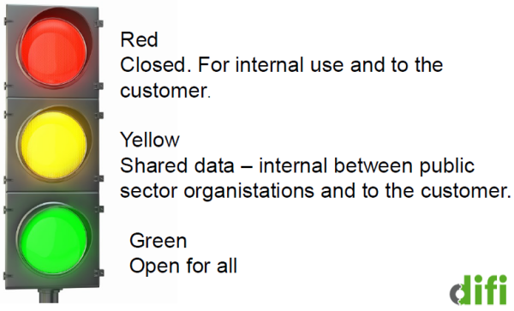
The traffic light system contributes to shifting the focus to sharing as the rule, rather than the exception. 'Open data' is as a natural consequence of the real goal that is to share data.

Management summary
Challenge and Solution
There are 3 main challenges which we are addressing here
- Potential for sharing within the public sector itself
The initial years of the Government’s open data actions were primarily motivated by creating new business opportunities and jobs in the private sector and improving openness. Potential efficiencies in the public sector were in many ways a secondary goal. However there has been a shift in recent years towards recognizing the huge potential which the opening up and sharing of public sector information can have on innovation and efficiency within the public sector itself. This is highlighted in a survey performed by the Office of the Auditor General of Norway in 2011, which found that 72 % of governmental agencies are aware of information that is held by other agencies, which would have been useful for themselves. And 55 % know about information they hold themselves that should have been made available to others. Government itself is emerging as a major consumer of public sector data and greater access is necessary.
When organisations consider data for release, they often only consider what can be released openly for all. However there is also a great deal of data which may not be relevant to be opened fully but is still highly valuable for the public sector itself. By concentrating on and identifying data which can only be released publicly for everyone we are potentially missing out on much of the data which other agencies would like access to, as is referred to in the Auditor Generals findings.
Coupled with this by including and specifically addressing the public sector here there is a natural cultural shift to recognise that ‘there is a lot in this for me too’ and further promotes the sharing culture in the public sector itself.
- The user knows what exists
There is often a ‘catch 22’ situation when identifying data for release. The public sector asks the user community what data they would like and they will prioritise this for release. However, the user community are often not aware of what exists and therefore cannot respond here. This is particularly the relevant now as many of the obvious examples and low hanging fruit have been released.
The overview when made public gives enough information for users (both public and private sector) to prioritise the most interesting data for release. Potential external users can also examine the data categorised as yellow and bring forward arguments about why some of it could be recategorised as ‘green’ data if they see fit.
- Speed up the data delivery process
Organisations are often tempted to initiate a long and thorough process before the release of any information. Instead we recommend the twin track approach, which is as follows.
[T]he perfect should not be the enemy of the good: a simultaneous 'publish early even if imperfect' imperative AND a commitment to a 'high quality core'. This twin-track policy will maximise the benefit within practical constraints. It will reduce the excuses for poor or slow delivery; it says 'get it all out and then improve'.
Some simple tools are necessary to assist in the idenitfication and release of some data early. The traffic light system contributes here.

Best Practice Identification

Why is this a Best Practice? What's the impact of the Best Practice?
The traffic light system is a best practice because of its simplicity. It is not designed to facilitate a deep and exhaustive mapping of data in an organisation, but rather it allows for an initial overview and categorisation to get the ball rolling. It ensures
- that the organisation gets an overview of their data including that which can be shared with other public bodies,
- that some data can be released swiftly, whilst the status of other data is clarified. Whereby, instead of waiting until everything is ready to be opened up the organisation can get moving on releasing data,
- that the basic overview can be published allowing for external parties from both the pucblic and private sector to know what tpe of data the organsiation holds and give input on which datasets to prioritise delivery.

Link to the PSI Directive
(Please use one or more of the categories listed on the last page of this document, as many as relevant)
- Open Data platform(s) / Publication and deployment of information/data and metadata
- Dataset criteria and priorities and value and scope w.r.t. datasets
- Techniques w.r.t. opening up of data / Technical requirements and tools
- Dataset structures, formats, APIs / Structuring of information/data, formats, APIs
- Data quality issues and solutions / Quality assurance, feedback channels and evaluation
- Documentation of information/data, creation of metadata
- Selection of information/data to be published according to various criteria
- Data discoverability

Why is there a need for this Best Practice?
- This has been addressed under the Management summary section.

What do you need for this Best Practice?
The only major requirement here is that someone has responsibility to perform this for the organization.
Technical requirements are minimal. Spreadsheet and the possibility to publish on line and receive feedback.

Applicability by other member states?
This best practice is applicable in all countries. Norway allows for a great deal of sharing of data within the public sector, which may not be the case in all other jurisdictions. In jurisdictions which do not permit similar levels of sharing, this will simply have the consequence of more data being categorized in the red rather than the yellow category.

Contact info - record of the person to be contacted for additional information or advice.
Heather Broomfield hbr@difi.no

Categories for use in section 3.2

- Policies and legislation (legal requirements, licenses etc..) / Licensing of information/data and metadata
- Open Data platform(s) / Publication and deployment of information/data and metadata
- Dataset criteria and priorities and value and scope w.r.t. datasets
- Charging issues and proposals
- Techniques w.r.t. opening up of data / Technical requirements and tools
- Organisational structures and skills
- Dataset structures, formats, APIs / Structuring of information/data, formats, APIs
- Encouraging (commercial) re-use
- Persistence and maintenance of information/data and metadata
- Data quality issues and solutions / Quality assurance, feedback channels and evaluation
- Documentation of information/data, creation of metadata
- Selection of information/data to be published according to various criteria
- Data discoverability

Both numbers have significantly increased since a similar survey in 2007 (36 % and 30 % respectively). We can assume that there has been a similar increase since 2011 aswell, however this has not been documented yet.
SHAKESPEARE REVIEW An Independent Review of Public Sector Information MAY 2013 pg. 11

