

A CTO’s Guide to Social Business
Version 0

July 3, 2012
Contents
A CTO’s Guide to Social Business
Version 0 1
Acknowledgements 5
Social Business Community Group 5
Additional Reviewers 5
Introduction 6
Mobility 7
Analytics 7
Cloud 7
Service Oriented Architecture (SOA) 8
Technical Components of Social Business 8
Sample Use Case: Business Process Visibility 8
Activity Streams 10
Gadgets and Embedding 10
Security 11
Social Graph 11
Summary of technical components applied to the business process use case 12
Getting Started 13
Step 1: Establish Strategic Vision 13
Step 2: Identify Initial Use Cases 14
Step 3: Develop a Social Business Technical Strategy 15
Business Process 15
Data Architecture and Social Analytics 15
Technology Architecture and Mobile Devices 16
Application Architecture and SOA 17
Technology Architecture and Cloud Computing 17
Step 4: Deliver a Proof of Concept before moving to production 18
Summary 18
Appendix A: The W3C Social Business Community Group 18
Works Cited 19
© 2012 W3C Social Business Community Group.

Acknowledgements
The Rapid Start Guide is a collaborative effort that brings together diverse customer-focused experiences and perspectives into a single guide for IT and business leaders who want to know more about social business. The following participants have provided their expertise and time to this effort.

Social Business Community Group
Alberto Manuel (ProcessSphere)
David Robinson (IBM)
Rich Rogers (IBM)

Your Name Here ( Your Company / organization here) - role

Additional Reviewers
The following reviewers provided feedback on the Rapid Start Guide:
Your Name Here (Your Company / organization here)

Introduction
The primary target audience for this paper is CIOs, CTOs, and IT architects who wish to better understand social business, its key technical components, and the technical implications to consider. 65% of Line of Business buyers will buy IT solutions without involving their IT staff, according to Forrester Research. Technical professionals need to be aware of social business trends and technology so that they can lead their organizations technical strategy as their organizations become social businesses. Social business is an emerging area, as is the technology that enables it. Adopting patterns from social networking into business settings is yielding new use cases that will drive new technology needs and the need for flexibility realized via open standards. Social business is quickly expanding beyond social media campaigns and employee blog sites. Social business intersects with other important IT trends. Forbes observes that “businesses faces a dynamic landscape where both customer and employee demands are changing. The world is changing, and there are three market shifts that are driving this change – mobile, social, and cloud. These trends change what we connect, how we connect and how we transact. “1
What is a social business? A social business is an organization that applies social networking tools and culture to business roles, processes and outcomes. A social business enables people to engage productively in a business context through collaboration and interconnecting business activities with social content. The scope of a social business spans across internal organizational boundaries and can extend to partners and customers. A social business monitors and analyzes social data to discover new insights that when acted on can drive business advantage, for example retaining customers, predicting market opportunities, and improving processes both internal and external. A social business recognizes that people do business with people and optimizes how people interact to accomplish organizational goals:
- Connecting individuals in productive, efficient ways
- Capturing and sharing knowledge
- Providing line of sight across traditional boundaries and better aligning actions to needs
- Speeding up business with insight to anticipate and address evolving opportunities

Examples of social capabilities applied in businesses today:
- Marketing and Customer Service. Focused on use of social networking for marketing purposes. Emerging into more sophisticated customer relationship management scenarios that employ analytics capabilities, for example brand monitoring via parsing and analyzing unstructured social content such as customer comments.
- Human Resources. Optimizing the workforce via collaboration software deployed to remove silos within an organization, improve information sharing and teaming, to achieve new innovation and more effective project teams.

Social business scenarios are emerging that are central to how work is accomplished in an organization. These will increasingly impact core systems within an enterprise. Consider for example supply chain business processes where social interaction is introduced to achieve more effective handling of business process exceptions, business process adoption and process improvement. These trends will increasingly reach deeper into an organization's core systems and impact enterprise architecture. Social business is not disjoint from enterprise IT strategy and execution, but rather an integral component.
What are the technical implications of these emerging social business scenarios? The W3C (World Wide Web Consortium), a community that drives open web standards, led a JAM, an online 3 day collaboration event, on the subject of social business use cases, and the standards required to support them – over 1000 people participated.2 Participants represented 20 industries, and included executives and thought leaders with varied backgrounds and specialties. One recommendation from the JAM was the need to sustain the focus on open standards for social business, and the result was the launch of the W3C Social Business Community Group, with a mission to “gather practical, business oriented, use cases focused on high value transactions to influence and improve existing social standards in order to foster the growth and adoption of social standards in enterprise solutions. “3
Here are brief introductions to some of the technical implications of social business that are important for technical teams to understand and address as they deploy social capabilities for an enterprise. Each of these topics will be addressed in more detail in the “Getting Started” section.

Mobility
Mobile devices are increasingly used in enterprises, and as such require mobile strategies that account for device allocation and management, for example BYOD or Bring Your Own Device, and security of corporate data stored on mobile devices. Mobility has become almost an essential part of social networking and this applies to social business as well. The always on, personalized attributes of mobile devices creates new scenarios for staying connected with colleagues and business tasks wherever the location.

Analytics
Social businesses require analysis of structured and unstructured content, for example to achieve brand monitoring by analyzing customer comments on social networking sites. Another example is analysis of social interactions occurring during the order fulfillment process in order to detect patterns and areas for improvement. Some analytics scenarios will require a scope that includes existing corporate data (orders, inventory, sales, etc.) and unstructured social data, for example to gain insights into client and partner satisfaction and to identify process improvement opportunities.

Cloud
Cloud computing models enable flexible and rapid deployment of social software. Transitioning into a social business is a process in itself and will require a flexible IT infrastructure, as demand for social capabilities increases, and integration with enterprise applications can change capacity requirements. There are multiple deployment and service models for cloud computing. Software as a Service, or SaaS, is one model particularly appealing to social business. The Cloud Standards Customer Council ⁷ suggests “consider SaaS for rapidly evolving business environments where new requirements are likely to emerge, such as social business and web campaigns.” 4

Service Oriented Architecture (SOA)
SOA is an architectural style now popular in many enterprises because of the flexibility that this approach enables. It is an evolved approach to enterprise application integration whereby applications, in addition to providing user interfaces, also provide and consume services that enable integration of data and reuse of functional components across applications. Social businesses will leverage SOA to integrate social capabilities and technologies with core enterprise systems.

Technical Components of Social Business
In this section we explore social technologies, how they are used, and the associated standards that enable open, flexible, enterprise architectures. The building blocks of social business start from two points of origin. On one hand there are a wide variety of consumer driven technologies and patterns that foster collaboration and new approaches to engaging the user and communities. On the other hand there are a broad set of technologies, standards, and services that drive existing line of business applications and systems. This point of convergence is where we start to drive new value and visibility to existing processes, applications and data. It's important to note that this transformation does not require a one size fits all approach. An effective approach is to start small and incrementally add capabilities over time.
It's important to understand the technology and the fundamental building blocks as social capabilities are added into the environment. There are a few fundamentals that the technology team will encounter as they look at social technologies. Here is a brief description of the key components and some of the existing and emerging standards, many of which are supported by open source implementations.

Sample Use Case: Business Process Visibility
A use case describes interactions between people and systems. Use cases are often used in software and systems engineering to capture and understand requirements. Here we introduce a use case to provide context and help illustrate how and why social technical components can be used to add value. Consider a business process defined for procurement. There are many participants involved, and that group of roles and individuals may change depending on the given procurement instance, for example a manager might only become involved if an order has been delayed or a project’s schedule has been shifted, a search for an import regulations person with a particular expertise might only occur when specific products are being procured from a certain country, a buyer may have insights into a lower cost alternative that still meets requirements. It is often impossible to identify all interested parties ahead of time because of the conditional nature of the process. The business process work flow may transition through systems unfamiliar to interested participants. Simply providing all possible participants access to these systems wouldn't help them use these systems or interpret the information that they are seeing, and may not be desirable from an access control perspective.
A social business offers new ways of addressing this challenge. It embraces the principle that interested parties will select to follow processes that are of interest to them, that information of interest can be aggregated and presented to those interested parties, and that this can be accomplished without violating security policies.
Figure 1 depicts a typical requisition process, with a pre-defined set of participants using email and enterprise applications. Secondary and tertiary consumers, who may have reason to understand status or provide insights that can add value depending on the content, scope, and flow of a given instance of the process, are disconnected from the process. This is an opportunity to apply social concepts and technologies to add new value.
You can download the full use case description from the W3C Social Business Community Group. 3 . The W3C Social Business Community Group takes a use case driven approach to identifying and defining gaps in technical component standards to be addressed as social business applications evolve. The group works closely with the relevant social business standards organizations to address these gaps.
Figure 1. Business Process Visibility Use Case
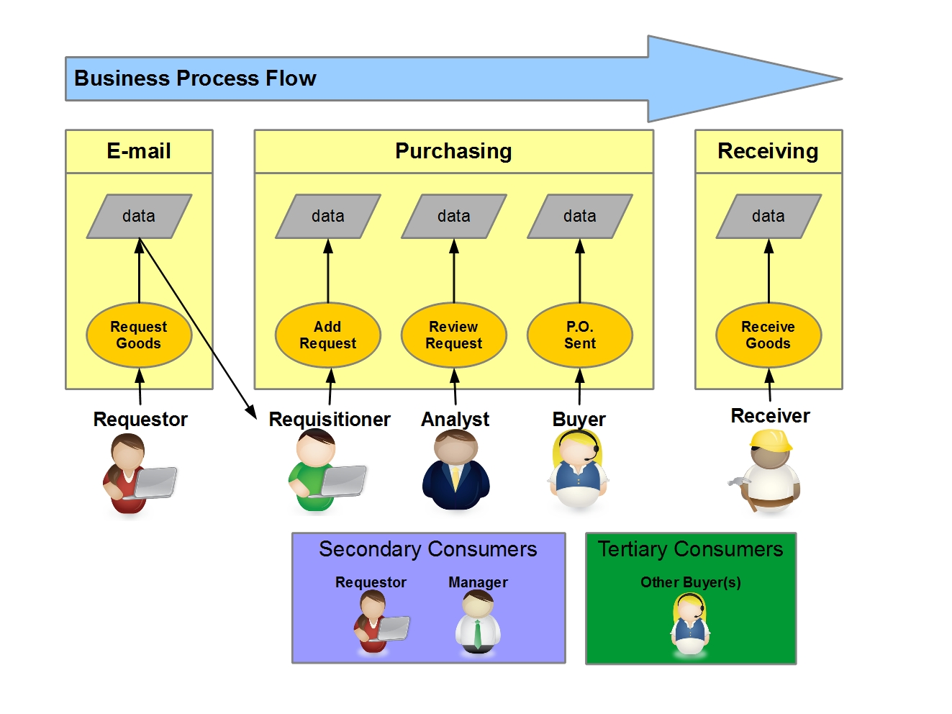

Activity Streams
An activity stream is a list of activities by individuals and groups usually within the context of a given application. Activity streams provide a mechanism to allow users to be notified when actions happen in their social network, for example Like, Follow, Post, or to share and re-share information. Similarly, social businesses use activity streams to simplify communications channels for people across their business network, with colleagues, partners, clients, and applications. In social businesses, activity streams can represent business activities, for example order fulfilled, sales lead identified, meeting scheduled, business documented posted for review. Activity streams complement traditional modes of communication like email, instant messaging and SMS.
The activitystrea.ms organization5 defines standards for activity streams that enable enterprise systems to publish and consume activity stream messages from across a heterogeneous set of enterprise applications. JSON, or JavaScript Object Notation, is a lightweight data format used in the activitystrea.ms specifications. Business information and activities of interest for a given person occurs in many applications across a given enterprise. Having a standard way to represent activity stream messages across applications enables sharing, presenting, and processing of messages at a scope required for social businesses.
In our business process visibility use case introduced earlier, interested users can follow business processes, and the result is the user's activity stream is populated with activities generated from different procurement business processes that are interesting to them. The activity stream becomes the aggregator of concurrent business processes and the neutral ground on which all parties can come together and collaborate. More advanced approaches will include business rules management capabilities so that users can personalize their settings. In popular social media applications you can manage settings such that you are notified if someone mentions you, or “likes” content you’ve shared. In business settings you may want to be informed when a business process reaches a certain condition, for example price threshold, or has certain attributes or combinations of attributes, for example import of product xx from country yy. These “requestors” can manage their activity stream settings in the way most appropriate for their work interests. Prioritization of messages within an activity stream is an example of a requirement defined at the W3C Social Business Jam and in subsequent use cases that the Social Business Community Group is now exploring in partnership with the activitystrea.ms organization.

Gadgets and Embedding
At the heart of most end user facing social applications are the familiar User Interface (UI) components supported on the web. HTML5, CSS and JavaScript are often the tools of choice to surface content to end users. OpenSocial Foundation has defined specifications for reusable UI components called gadgets that can be included in web applications. Gadgets can be secured with OAuth standard implementations to provide a means to securely surface content and function from core applications into social web applications.
Embedding is one way to make it easier to take advantage of common tagging techniques in your business content. Embedding often refers to the ability to embed business logic via JavaScript injection into any page to incorporate simple social functions such as "Share", "Like", "Comment", etc. Embedding can be used in combination with Activity Streams – embedding standard logic in the activity stream message such that clicking on the message launches an OpenSocial gadget with function of interest for that activity – for example an order exception activity embeds a gadget that integrates with the order management system to retrieve order details and enable quick response. A common integration model will be based on a service oriented architectural approach, typically realized via the use of REST style interfaces or web services. An advantage of embedding is that it allows users to quickly move from notification to taking action to accomplish business tasks quickly without changing application context.
In our procurement process example, a procurement activity is posted to the activity stream that indicates a specific process exception condition has been reached. This activity can include an OpenSocial Embedded Experience that is used to get dynamic status information from the purchase order system that is scoped to the visibility appropriate to the viewer. The user could also post a comment with suggestions on how to resolve the exception.

Security
Social solutions have adopted a wide variety of technologies and standards to help address the federated nature of identify and access to data across disparate systems. These build on identity related standards like OpenID and more recently OpenID Connect. Other security mechanisms like OAuth enable delegated authorization across different systems. Many have started to bridge these same capabilities to coexist with traditional business security mechanisms like SAML and Kerberos that are often present in service oriented architectures.
In our procurement use case there are certainly security considerations. Access control is critical, separation of duties requirements cannot be violated. When we consider exposing procurement information outside of the purchase order application to a “social” environment the initial reaction may well be that we have controlled access to this application and its data for valid business reasons and we cannot introduce new risks. The reality is that scoping and visibility can be managed via OAuth or through traditional access control models. For example, a Requestor may only be able to view the estimated arrival date of their order but not details like the financial information related to the order that may also exist in the PO system. The Requestor no longer has to wait for a status meeting or get time with her Requisitioner in order to get updates on her order, the information comes to her.
Tertiary parties, like a Buyer, can also tune into Procurement activities within his activity stream. They also would receive scoped visibility appropriate for them but can use the Social platform to be a neutral ground for some social collaboration. The Buyer could comment on an activity for a new PO that had been entered into the PO system, “Why don't you consider this lower cost alternative?”

Social Graph
A social graph defines the relationships between people, and between people and objects. The graph defines the social network and includes attributes about the participants. A social graph is realized as a data structure that is capable of describing these relationships and attributes. Examples in consumer social applications include relationships between people, for example John is friends with Mary, or relationships between people and objects, such as Bob posted a photo. In a social business, examples of information contained in the social graph are:
- Sally is the account manager for customer xyz
- Bill manages George
- Steve answered questions about international procurements
- John monitors the computer hardware procurement process
In the last example, the two objects are John and the hardware procurement process, and the relationship is “monitors”.
In social business, a social graph can be a source of information to be analyzed and queried, for example to identify experts for a given business process that can most effectively resolve an exception. In our procurement use case, as the process enters an exception state, analysis of a social graph may identify experts to engage to most effectively resolve the exception, based on combinations of factors such as their role, content they have contributed in the past, and their profile. In consumer social applications, typically the application defines and manages its own social graph.
Social graphs can become significantly more complex than basic node-relationship-node models depending on the questions that need to be answered from the social graph. Open standards for social graphs will make it possible to easily share social graph relationships among applications. This ability to combine social graph information from across a set of enterprise applications makes the aggregated social graph more robust and more valuable in terms of queries that can be performed, and analytics that can be applied. One example is the ability to assess business events against the social graph and determine who should be informed. Open standards for social graphs enable more advanced scenarios, where systems will be able to determine user interest. This is a more advanced scenario of the use of activity streams, where users are informed not necessarily because they chose to follow something or someone, but because evidence exists in their social graph that they are likely interested in a given topic. For example, because John monitors the hardware procurement process he probably wants to know that Sally just approved a new supplier.

Summary of technical components applied to the business process use case
In our procurement business process use case, we explored the use of Activity Streams to empower authorized users such as requestors and buyers to define and configure their interests in business process activities and be informed as those conditions are met. We described embedded experience within the Activity stream and the use of OpenSocial standard technologies to provide a rich, personalized experience where users can navigate from the activity stream directly into the appropriate functional capabilities of the underlying core systems, which in this case is the purchase order application. We provided insights into how this can be done in a secure manner. Finally we defined the social graph and its value in areas such as expertise location for more effective business process management. Throughout this section we explained the importance of open standards for social business and provided examples of some that exist today and where more is needed. Figure 2 depicts the use of social technical components including activity streams, embedded experience, and OpenSocial gadgets to increase the visibility of and create the opportunity to participate in the business process for additional consumers (for example the requestor).
Figure 2. Technical components applied to use case
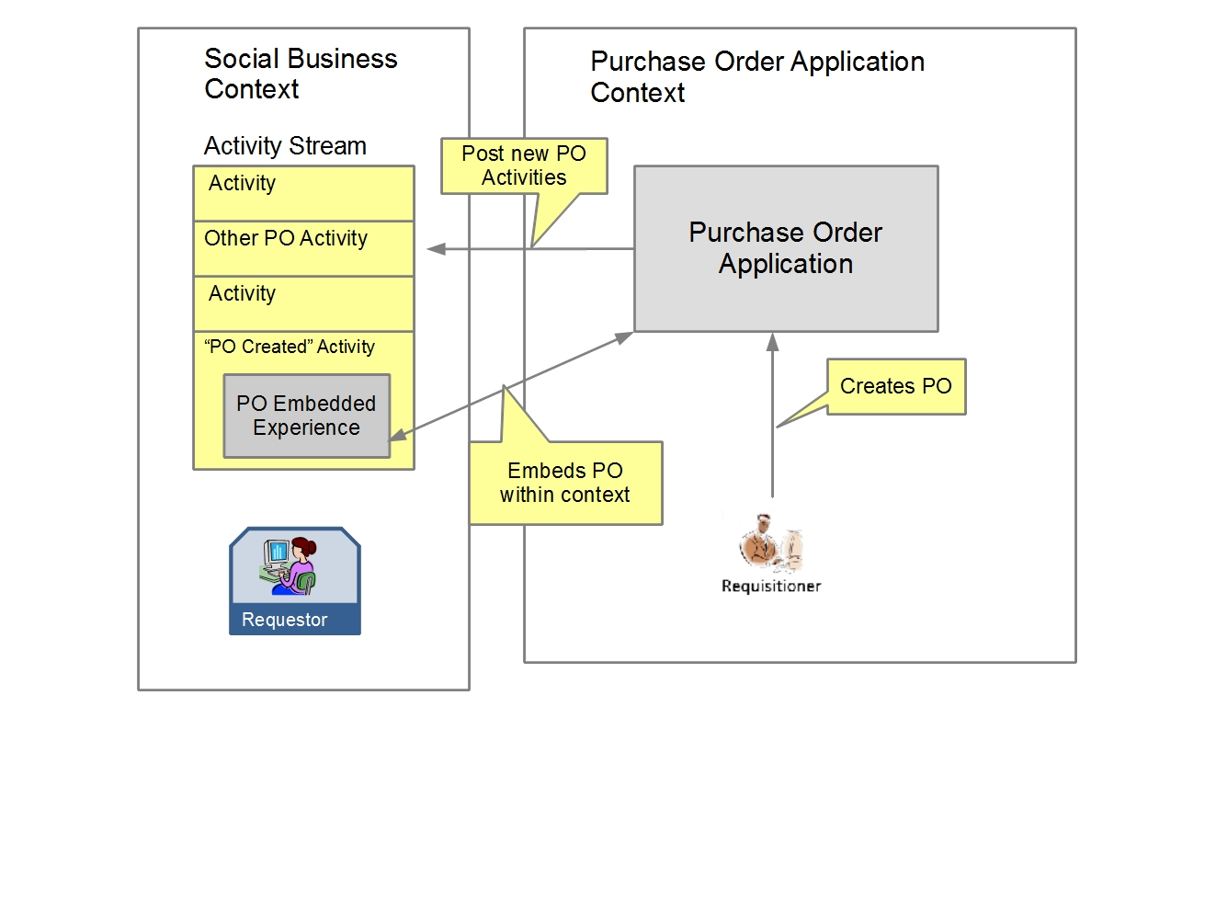

Getting Started
In this section we provide guidance on getting started, taking into account the technical implications that were briefly described in the introduction section (Mobile, Cloud, SOA, Analytics).

Step 1: Establish Strategic Vision
In the beginning, an organization may not be able to fully articulate how they will become a social business. They may well need to explore possibilities via proof of concept and pilot projects. However it is important to have executive level leaders establish that social is important for the company. During this strategic phase, the CEO and the senior management team including Line of Business Executives and the CIO lead the organization to establish the vision for the organization. Social business is not typically an IT led initiative; in fact its attractiveness is the ability to provide significant business value which is why lines of business are embracing it. However, IT needs to be directly involved from the start and lead in the IT transformations required. Social businesses realize fundamental changes in many of their key processes and these changes have IT implications. Some initial projects may be silo efforts that have little impact on existing systems, however expansion into higher value capabilities will inevitably carry IT implications. Even silo projects may carry IT implications in terms of enterprise policy regarding mobile devices, security, and data access for example. Having a solid executive understanding and endorsement from executive leadership is key.

Step 2: Identify Initial Use Cases
Forbes notes that social and mobile will:
“change how businesses engage with its customers and employees. Social is changing the way firms market and deliver customer service. But social isn’t something that is reserved for consumers. Social software is changing our enterprise collaboration tools and its changing engagement within business apps such as CRM. Game mechanics are being used in retail for B2C but also in business environments for rewards.”
Initial use cases may come from line of business teams, or could be initiated by technical teams. One approach to categorization of use cases is:
Enterprise: use cases whose scope is “intra-enterprise”, focused on improving operations, such as our procurement business process example, or establishing new software for project collaboration and content sharing.
Business to Consumer (B2C): B2C examples include marketing via social media, customer service and brand monitoring via monitoring consumer social applications.
Business to Business (B2B): B2B can include marketing scenarios as well as operational scenarios, for example when partners are part of a supply chain process.
Initial use cases should be selected with a consideration for scope that will:
- Be measurable and have a business impact.
- Exercise key technical considerations. Initial use cases should inform the IT leadership on implications and adjustments to technical strategy, for example in the areas of mobile device usage policies, security, application integration, computing infrastructure, data implications.
- Be a starting point. Can stand on their own and deliver business value yet also be expanded upon to provide additional value incrementally.
Our procurement business process example is an example of an initial use case with sufficient scope to meet the above criteria.

Step 3: Develop a Social Business Technical Strategy
A social business technical strategy needs to be an integral part of an organization’s enterprise architecture. Gartner defines enterprise architecture as “the process of translating business vision and strategy into effective enterprise change by creating, communicating and improving the key requirements, principles and models that describe the enterprise’s future state and enable its evolution.” 6
The Open Group has defined an enterprise architecture framework, one of the most widely adopted in industry, to illustrate. TOGAF (The Open Group Architecture Framework) 7 defines four types of architecture that are commonly accepted as subsets of overall enterprise architecture:
- A Business (or Business Process) Architecture - this defines the business strategy, governance, organization, and key business processes.
- A Data Architecture - this describes the structure of an organization's logical and physical data assets and data management resources.
- An Applications Architecture - this kind of architecture provides a blueprint for the individual application systems to be deployed, their interactions, and their relationships to the core business processes of the organization.
- A Technology Architecture - this describes the logical software and hardware capabilities that are required to support the deployment of business, data, and application services. This includes IT infrastructure, middleware, networks, communications, processing, standards, etc.
A social business technical strategy will intersect with the enterprise architecture:

Business Process
Social business may drive changes in key business processes, for example in customer relationship management, supply chain management, and enterprise resource planning, where social patterns are applied to improve those processes.

Data Architecture and Social Analytics
Social analytics is concerned with the data representing the interactions between people, and between people and objects. Data architecture may be affected by a combination of:
- New data sources, for example. external data sources such as brand monitoring of consumer social applications
- New data types, for example identity, profile, and social graphs.
- requirement to manage and query unstructured content produced by employees, customers, and partners
- enable analysis against combinations of social data (customer comments ) and other enterprise data (order history)
- Master data management capabilities to uniquely and consistently identify and describe people and objects across systems.

Technology Architecture and Mobile Devices
Mobile devices bring an entirely new dimension to social business. Mobile devices are different from other portable devices such as laptops or even net books because they are almost always on. There is something more personal about mobile devices than any other type of device, and people are more willing to be interrupted and respond to information that arrives to their mobile device than to other devices. This always on, always available characteristic of mobile is frequently called “presence”.
The concept of presence or knowing “where I am now” enables many unique social scenarios. In consumer facing business scenarios, for example, “I am currently at the cinema” or “we see you are near our store, come in and see our sale” can be leveraged by businesses. The concept has equal relevance in the social business arena. Consider being at a conference and being able to ask the question “is anyone I know in the auditorium right now?” based on the knowledge of where their mobile devices are. These are all social scenarios that are enabled by mobile devices.
Certain social technologies, in particular, activity streams, SMS messages, Instant Messaging (IM) and even e-mail lend themselves readily to use on mobile devices. Employees can interact with their business from their mobile device in a format that is comfortable in a mobile, small screen size format.
Businesses must consider that, because of the personal nature of mobile devices, that it is easier to intrude and create the “always at work” impression for their mobile employees. Selecting the correct set of social technologies for mobile devices can allow for the rapid contact and dissemination of information as well as the participation of the employee, without becoming overly intrusive. This is a particularly relevant conversation considering that most employees purchased and own the mobile device, and that it was purchased as much for personal use as it was for business. Businesses are having to adapt to the “Bring Your Own Device” (BYOD) mindset that is now prevalent World wide.
Location information is now available not only from mobile devices, but also on desktop systems, especially in browsers. However, because the location of mobile devices changes frequently, that information can be used to customize the business information that is presented to a user on their mobile device. Information can be sorted, filtered or prioritized differently depending on the location of the employee. Some business are even exploring auto the provisioning and un-provisioning of certain business applications onto mobile devices depending on the location of the device (for example, only allow that application to run when we know the device is on one of our networks).
Mobile devices present some specific security challenges. The capability to remotely wipe a device of confidential information in the event the device is stolen or an employee leaves the company is a very important aspect to mobile device management. Likewise, finding lost devices using secure presence information is increasingly a need expressed by business people (especially those in charge of corporate security management).
Social business applications for mobile devices can range from native applications specific to that device’s operating system, to hybrid applications that leverage both the browser and the native operating system, to solely browser based applications. There are advantages to any of the approaches for providing social content. In the recent past, browser based social applications suffered from a lack of functionality and common look and feel from other applications on a mobile device. As HTML 5 matures, browser based applications are beginning to contain as rich a feature set as native applications.

Application Architecture and SOA
Service Oriented Architecture (SOA) encapsulates application functionality and exposes that function via standardized services, typically for integration and reuse purposes. This approach can be highly effective when it is desired to utilize core enterprise software in new ways and with new technologies. As organizations made the transition to web based enterprise applications, a key challenge was that extensive and complex core business logic was embedded in legacy applications, for example mainframe applications. Rebuilding all of that logic in “web friendly” programming languages was not an option. Exposing the legacy software as services that are consumable by a variety of applications became a preferred approach for many. Social business patterns present a next wave of exposing and interacting with core business logic, in this case with technical components such as OpenSocial gadgets, on new interfaces such as tablets and smartphones. From an application architecture perspective, the SOA style is well suited for social businesses. There may be new considerations regarding technical interfaces to consider, adjustments and additions in the services interfaces provided. As an example, REST style services are popular among social technologies.

Technology Architecture and Cloud Computing
The National Institute for Science and Technology (NIST) defines cloud computing as follows:
Cloud computing is a model for enabling ubiquitous, convenient, on-demand network access to a shared pool of configurable computing resources (for example, networks, servers, storage, applications, and services) that can be rapidly provisioned and released with minimal management effort or service provider interaction. 8
Cloud computing implementations enable flexible and rapid deployment of social software. There are multiple deployment and service models for cloud computing. Software as a Service, or SaaS, is one model particularly appealing to social business. The Cloud Standards Customer Council 7 suggests “consider SaaS for rapidly evolving business environments where new requirements are likely to emerge, such as social business and web campaigns.” 4
Using social technologies and SOA to increase availability of core business function and information can have potential implications on system performance and availability. Usage patterns may change. Application demand may increase or decrease. Also, adoption of social technologies within an enterprise may increase at unpredictable levels. Demand may be slow at first but increase exponentially and unpredictably as a given social solution becomes more popular. Cloud computing models provide the flexibility to rapidly adjust to changes in demand realized from introducing social technologies and solutions.
Cloud based offerings can be an effective approach to providing social solutions for business partner interactions, or to provide collaborative capabilities that bring together an enterprise where different groups use have different technology environments. An example would be merger and acquisition scenarios where the new organization wants to begin working together and collaborating quickly yet the legacy IT environments are very different, not integrated, and will take some time and investment to address.

Step 4: Deliver a Proof of Concept before moving to production
Once there is agreement on initial use case(s) the next step is to assemble a proof-of-concept (POC) team which includes the following:
- Information Technology. The team includes architects, systems administrators, development, and customer support (help desk).
- Functional representative. The team includes a designated individual within the enterprise who can represent business user expectations.

Consider PoC implications with regard to technical strategy. A PoC should:
- Validate existing strategy and/or identify gaps & concerns with existing strategy
- Inform on areas where strategy and policies are being developed or need to be developed.
Assuming that the POC is successful and meets or exceeds expectations, a production implementation can be delivered.

Summary
Becoming a social business has technical implications. Social businesses adopt new technologies and patterns. To support the transformation to a social business, adoption of these technologies must be managed as part of enterprise architecture. Social business technologies combine with and leverage other key technical trends such as analytics, service oriented architecture, cloud computing, and mobile. IT leaders must educate and partner with the lines of business leaders to successfully realize a strategic transformation to social business.

Appendix A: The W3C Social Business Community Group
We are in the formative stages of social business. Beyond pilots, beyond the getting started use cases, are new and emerging use cases of value, and there are certainly use cases yet to be created. What we know is that whether enterprise, B2B, or B2C, an open standards based ecosystem will most readily enable desired use cases to become reality with more flexibility of choice, with less time and cost. The real value of social business will not be realized if manifested as islands of point solutions. As social business becomes more pervasive, integration with core business systems, and across social platforms, will be desired. As we have seen with recent paradigms such as service oriented architecture (SOA) and Cloud, open standards are the enabler of this desired flexibility. The W3C Social Business Community Group is in place to define social business use cases that matter to businesses and drive the open standards based ecosystem needed to support those use cases.
The mission of the Social Business Community Group is to “gather practical, business oriented, use cases focused on high value transactions to influence and improve existing social standards in order to foster the growth and adoption of social standards in enterprise solutions.”5
Consider joining the W3C Social Business Community Group. There is no membership fee, even if your organization is not currently a member of W3C. The W3C Social Business Community Group is a gathering place to understand the value of applying social concepts to business, share best practices with peers and subject matter experts, and influence the evolution of social business standards. The group is also producing a diagram to represent the various components of importance to social business, and the current standards landscape overlay, in order to identify and prioritize standards requirements for social business. Join the group and contribute your ideas.
For information on the Social Business Community Group, including how to join, visit this link - http://www.w3.org/community/socbizcg/

Works Cited

- “Three Trends that Change Business. Mobile, Social, and Cloud”, Forbes, http://www.forbes.com/sites/maribellopez/2012/01/28/three-trends-that-change-business-mobile-social-and-cloud/
- W3C Social Business Jam, http://www.w3.org/2011/socialbusiness-jam/report.html
- W3C Social Business Community Group, http://www.w3.org/community/socbizcg/
- Cloud Standards Customer Council, http://www.cloud-council.org/
- http://activitystrea.ms/
- Gartner, http://www.gartner.com/it-glossary/enterprise-architecture-ea/
- The Open Group, http://pubs.opengroup.org/architecture/togaf8-doc/arch/
- Mell, P., & Grance, T. (2011). The NIST Definition of Cloud Computing (Draft): Recommendations of the National Institute. Gaithersburg: National Institute of Standards and Technology. http://csrc.nist.gov/publications/drafts/800-145/Draft-SP-800-145_cloud-definition.pdf This white paper defines cloud computing, the five essential characteristics, three service models, and four deployment models.

