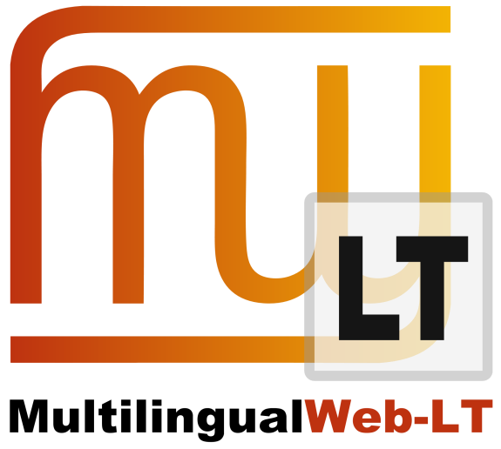

5D1.2.1: Deliverable Title

David Filip, Felix Sasaki, other authors
Distribution: Consortium Internal Report

MultilingualWeb-LT (LT-Web)
Language Technology in the Web
FP7-ICT-2011-7
Project no: 287815

Document Information
Deliverable number: | 1.2.1
Deliverable title: | Report on Internal and External Communication Tools
Dissemination level: | CO
Contractual date of delivery: | 31st March 2012
Actual date of delivery: | 31st March 2012
Author(s): | @@@@
Participants: | UL, DFKI
Internal Reviewer: | TCD
Workpackage: | WP1
Task Responsible: | @@@@
Workpackage Leader: | Felix Sasaki

Revision History
Revision | Date | Author | Organization | Description
1 | 26/03/2012 | Felix Sasaki, Pedro Diaz | DFKI, Linguaserve | Compiling information and discussion
2 | 27/03/2012 | David Filip | UL | Draft
3 | 28/03/2012 | David Filip | UL | Penultimate Draft
4 | 30/03/2012 | David Lewis | TCD | Revised Version

Contents
Document Information 2
Revision History 2
Contents 3
1. Executive Summary 4
2. Introduction 5
3. The Communication Set up 5
3.1. Mailing Lists 5
Email communication tags 6
LT-Web Mailing List 6
WG Administrative Mailing list 6
WG Public Mailing list 7
WG Public Comment List 7
Lists inherited from the MultilingualWeb project 7
3.2. Teleconferences and Face to Face Meetings 7
3.3. Action Item and Issue Tracking 8
3.4. Wikies 8
LT-Web Wiki 8
WG wiki 8
3.5. Webpages 9
WG Webpage 9
MultilingualWeb webpage 9

- Executive Summary

