**Purchase Behavior Data Used in a “Closed-Loop” Powers More Effective Digital Advertising**

Satya Satyamoorthy  
Director of Development  
Nielsen Catalina Solutions

## Introduction

For many years, consumer packaged goods (CPG) brands planned their media campaigns using demographic segments derived from research about the age and gender of their core customers as a “proxy” to plan, buy and measure media. Demographic segmentation typically reaches customers as they are distributed in the general population for mass media, such as television.

Traditionally, marketers relied on demographic data in addition to other information, to define and reach their customers with media, and to customize and deliver content relevant to the audience. This was simple as there is limited number of demographic categorization such as age, gender, city, state, zip, ethnicity etc. This also allowed mass distribution of the same content. For traditional television, the media has been purchased based on age/sex demographics using Nielsen “currency” data.

Today, with the emergence of precision marketing and big data, it’s apparent that a demographic-based approach is wasteful at best.

## Purchase behavior-based Approach

One of the tools for precision marketing is to use the Brick and Mortar or offline purchase data for media activation, with digital being the most mature. This means to augment and/or replace demographic-based segmentation with purchase behavior-based segmentation of potential customer households.

Nielsen Catalina Solutions (NCS) has the largest single source database for the CPG and OTC verticals. print NCS integrates actual retail sales data from 70+ million HHs from Catalina with media viewing into a “total household view,” enabling advertisers to plan, activate and optimize media, then measure the resulting incremental sales for all media platforms including TV, Digital, Mobile, Print, Radio, and CRM.

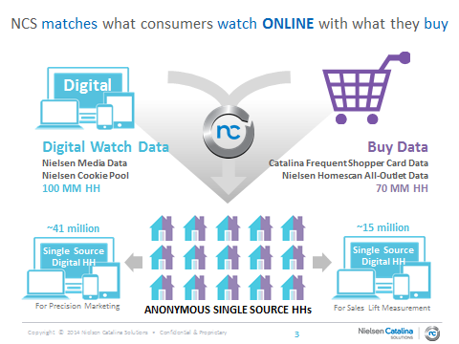

Note that the single source households are anonymous and aggregated to protect privacy.

Based on several studies and targets that were delivered to our clients we find that demographics are, in fact, a poor predictor of purchasing behavior, especially for television. In the NCS study, “Deconstructing Demographics,” More than half of all household sales for average CPG brand fell outside of the demographic group that was targeted by advertisers, in this case, women 25 - 54.

## Deficiencies of Demographics alone

Looking at more than 10 leading CPG brands that account for more than $415 MM on measured TV in 2011, we found that:

* *Demo-based media plans over-deliver to low-value consumers*
  + The average brand in the study delivered 64 percent of television media exposures to households accounting for 2 percent of sales among the heavy buyers
* *Demo-based media plans under-deliver to brands’ best consumers*
  + A mere 36% of exposures reached the households that accounted for 98% of brand sales among the heavy buyers
* *Common demo targets miss a majority of sales volume*
  + Households headed by women aged 25-54 provided just 47 percent of sales for the average brand

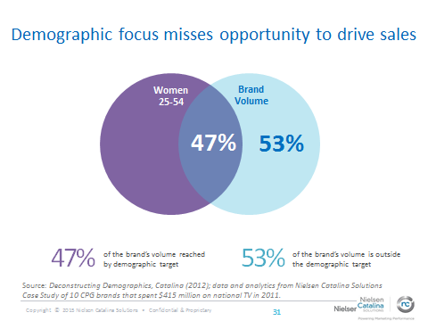

As it was found that using demographics as a proxy for buyers was missing the mark, it was attempted to segment households based on actual offline purchase behavior. The households were classified as Heavy Buyers, Medium and Light buyers, Switchers and Loyalists. The classification was based on the amount and frequency of purchasing the category and brands.

A study of over 800 digital campaigns showed that the average payback for all CPG categories was 2.79, ranging from 2.36 for food items to 5.29 for the pet category. A payback of 2.79 means that for every dollar spent on advertising returns nearly three dollars in incremental sales.



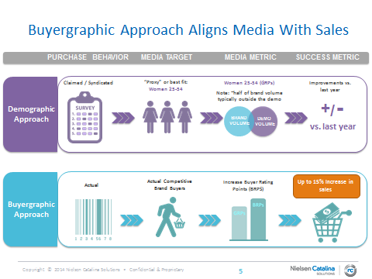

## The Rise of In-Flight Optimization

Digital campaigns can now be optimized for sales performance while the campaign is still running or “in-flight.” Any tag-able element can be optimized, including multiple audience segments. Once a campaign has been running for approximately 4-weeks, there is enough data to determine which of the variables are performing the best for driving incremental sales. Impressions can be shifted from the weaker performing variables to the better performing variables. A major digital media company executed an NCS campaign using In-Flight Optimization during the campaign and measured the sales results at the end. In-Flight Optimization results were delivered throughout the campaign, giving the publisher the opportunity to reallocate impressions to the campaign tactics using a Key Performance Indicator (KPI) of incremental offline conversions (the effectiveness index). As a result, the brand recognized a $3.12 return on ad spends and a 5% lift in sales, and consumers exposed to the campaign were making the brand a larger part of their purchases within the category.

## Conclusion

In summary, Consumer packaged goods (CPG) brands can experience a return an average of almost three in incremental sales for every dollar spent in online advertising that has been precisely delivered using purchase-based information.

Historically marketers were relying on the demographics for planning and buying media. Today with the advent of new technologies and “Big Data” in particular, we have the ability to link advertising exposure to actual retail sales in a single source view, enabling marketers to significantly improve the effectiveness of their advertising. These new data and tools provide precision marketing, better reaching buyers of their brands, increasing the efficacy of marketing and increasing the Return on Ad Spend (ROAS).

## References:

* Deconstructing Demographics - How Demographic-Based Media Plans Miss the Mark for CPG Advertisers, Catalina Marketing 2012
* Several Client studies executed by Nielsen Catalina Solutions 2010-2015.