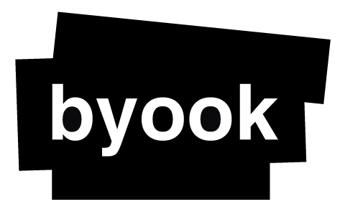
Position paper:
W3C Workshop on Electronic Books and the Open Web Platform
Pierre Serin, Byook SAS

Participant’s interest
Created in 2009, BYOOK is a publisher of enhanced ebooks. We believe our byooks reading apps will revolutionize reading habits. The company’s twenty-person team specializes in creating thrilling, action-packed stories to engage all of the readers' senses. The team is composed of talented graphic designers, skilled developers, and mobile app and video game marketing and sales experts.
The byook is very simple to use: just turn each page to reveal unique images enhanced by sounds and motion. Cleverly paced, the byook immerses you in the story by capturing all your senses. Any genre can be adapted to the byook experience: classic literature, young adult and children's stories, mysteries, horror and fantasy.
Today BYOOK wants to expand its horizon and release enhanced book not only on mobile device but also on epub and on the web.
Point of View
To make a truly interactive and enhanced book, the epub format is lacking in some aspects:
- Making a true client / server interactions: If you want to make a gamebook series it would allow you to save the reader’s character and its statistics across books, or to make a progression saving feature.
- Giving tools for social networking: With client / server interactions epubs can be more than just books; it can be used for magazines, or catalogs. Being able to share what you like, or what you created could be a key aspect that allows publishers or companies to see epub as a great marketing / viral tool.
- Offline mode: With those network enhancements, it feels natural to have an offline mode feature, allowing the reader to enjoy his epub even when far from home.
- WebGL: Bringing the power of OpenglES 2 and GLSL to epub3 could bring even more outstanding enhancements.
- Multi-package distribution: When you look at a store today you see 2 main issues. The first is related to the size of an epub, especially with epub3 and all of its new features. The second is that you can find multiple versions of the same book but with different content and different prices. Allowing publisher to have multiple package could address those two issues, and make life easier when it comes to do multiple version (with commentary, collector, with illustrations, without illustrations …)
- Media queries: Bringing the full power of media queries could help publishers to adapt their publications for a great number of devices.
- SVG: Vector design could help publisher making responsive epubs.

